Customer Shopping Behavior Analysis

- Project Overview:

This project analyzes customer shopping behavior using transactional data from 3,900 purchases across various product categories. The goal is to uncover insights into spending patterns, customer segments, product preferences, and subscription behavior to guide strategic business decisions.

- Dataset Summary:

-Rows: 3,900
- Columns: 18
- Key Features:
- Customer demographics (Age, Gender, Location, Subscription Status)
- Purchase details (Item Purchased, Category, Purchase Amount, Season, Size, Color)
- Shopping behavior (Discount Applied, Promo Code Used, Previous Purchases,
Frequency of Purchases, Review Rating, Shipping Type)
- Missing Data: 37 values in Review Rating column

- Exploratory Data Analysis using Python (EDA):

We began with data preparation and cleaning in Python:

● Data Loading: Imported the dataset using pandas.

● Initial Exploration: Used df.info() to check structure and .describe() for summary statistics.

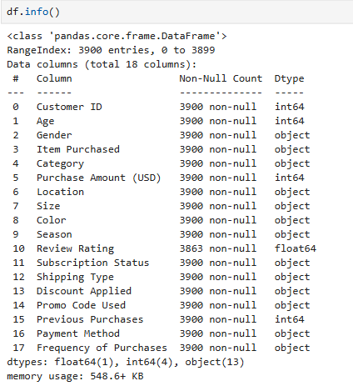
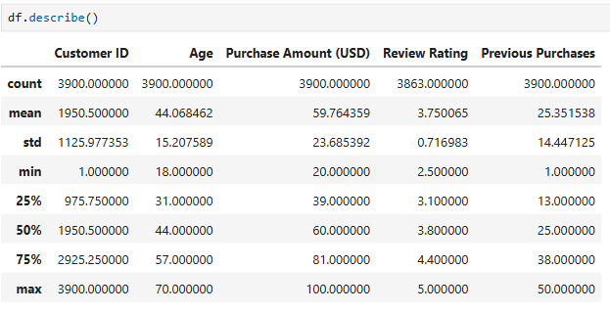

- Missing Data Handling:
Checked for null values and imputed missing values in the Review Rating column using the median rating of each product category.
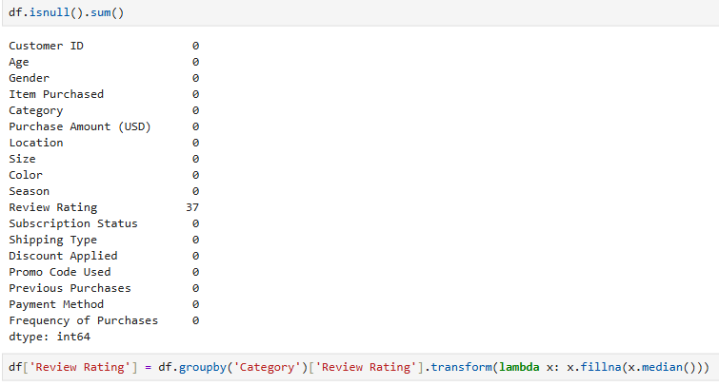

- Column Standardization:
Renamed columns to snake case for better readability and documentation.

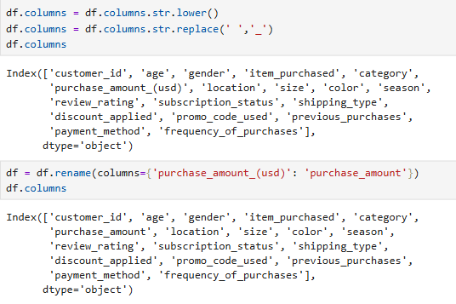

- Feature Engineering:
○ Created age_group column by binning customer ages.
○ Created purchase_frequency_days column from purchase data.
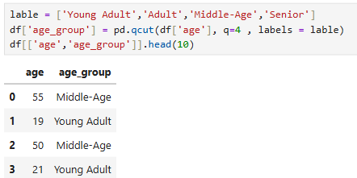

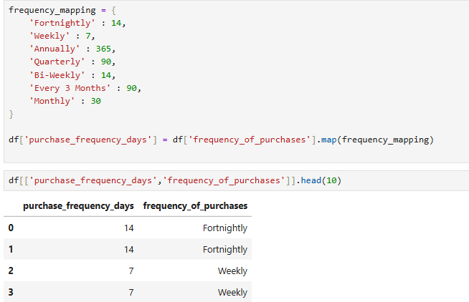

- Data Consistency Check:
Verified if discount_applied and promo_code_used were redundant; dropped promo_code_used.

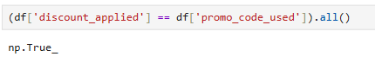
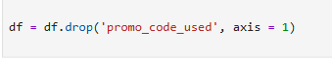

- Database Integration:
Connected Python script to MySQL and loaded the cleaned DataFrame into the database for SQL analysis.
